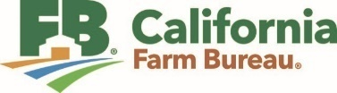
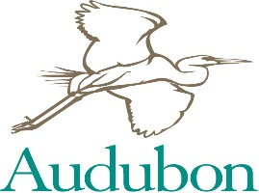
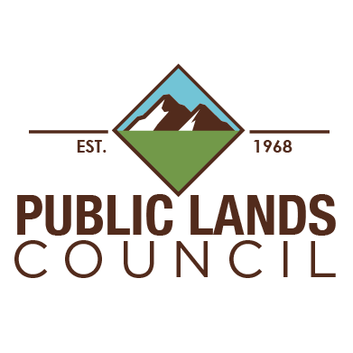
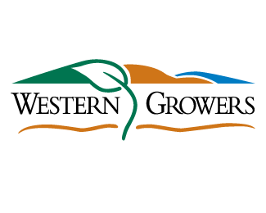
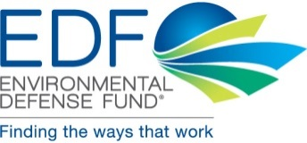
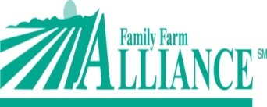
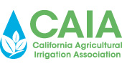
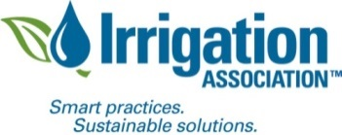
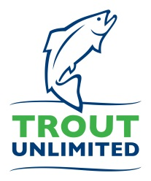
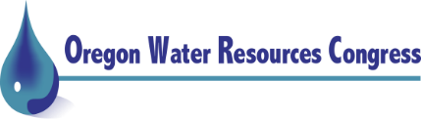
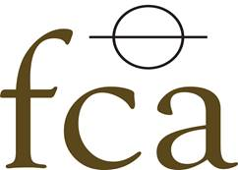

Western Agriculture and Conservation Coalition

March 31, 2021

Senate Committee on Environment and Public Works
Chairman Thomas Carper, Ranking Member Shelley Moore Capito

Senate Committee on Energy and Natural Resources
Chairman Joe Manchin, Ranking Member John Barrasso

House Committee on Transportation and Infrastructure
Chairman Peter DeFazio, Ranking Member Sam Graves

House Committee on Natural Resources
Chairman Raul Grijalva, Ranking Member Bruce Westerman

Re: WACC—Western Water Infrastructure Priorities to Build Climate Resilience

Dear Chairmen and Ranking Members,

The Western Agriculture and Conservation Coalition (WACC) urges your committees to invest in western water infrastructure that supports our working lands and our rivers. Our group has been working together for almost 10 years to develop the programs for such investments that meet the needs of diverse stakeholders and that will be durable through the passage of time. We look forward to working with you all to create effective infrastructure investments to meet the challenges of extended drought and water scarcity for both producers and fish and wildlife.

The WACC was formed in February 2012 to support the common interests of agriculture, conservation, and other interests tied to resources on behalf of a viable and sustainable rural West. No other national coalition combines industry and conservation interests to advocate for resource sustainability for all. We believe that unless agricultural producers and conservation come together, the public policies and resource management strategies necessary to maintain a viable and sustainable rural West will be impossible to achieve. In the context of western water, this means the WACC supports multi-stakeholder processes to address basin-scale water scarcity conflicts. To make such efforts successful, the WACC urges you to support investments in irrigation and municipal water infrastructure that provide important co-benefits of enhanced drought resilience and aquatic habitat. Below, we detail ways to make these essential and successful western water infrastructure investments.

- Invest in Multi-Benefit Irrigation Infrastructure Repair and Modernization.
The WACC supports increased investment in irrigation infrastructure projects that not only provide needed upgrades to aging water-delivery systems, but that can also enhance stream flows for better conveyance of surface water to points of diversion and better aquatic habitat. Our water supply and delivery systems are not getting any younger, and in some cases are becoming less reliable without significant additional investment in rehabilitation and upgrades. Congress recently authorized an aging infrastructure revolving account at Treasury as a way to provide affordable financing to fund such projects that can help keep our water flowing to farms and ranches across the West as well as providing helping to protect the environment through more efficient and modernized infrastructure.

WACC members’ deep experience in multi-benefit water delivery infrastructure projects have led them to emphasize five keys to unlocking multi-benefit infrastructure:

- Define Shovel-Ready such that it includes projects that can proceed to construction between 1-3 years from date of project application so that the best projects have time for project permitting and final design work to incorporate co-benefits such as improved streamflows, fish-friendly hydropower, or co-locating fiber optic cable along ditch easements;
- Invest in Project Planning for some projects so that project planning dollars enable projects that meet high goals for providing multiple benefits through water infrastructure projects;
- Provide Higher Federal Cost-Share for those best-in-class projects to produce benefits such as burying energy transmission lines along with buried pipe in order to reduce wildfire risk from exposed lines;
- Delay Match Repayment for the non-federal share over a decade, creating a revolving fund of incoming reimbursement dollars for federal funds advanced to cover full project costs initially, to enable support for additional projects over time; and
- Coordinate Permitting across Federal Agencies and facilitate state and federal agency coordination to advance project planning and execution.
Examples of WACC members implementing these principles include the Three Sisters Irrigation District (TSID) piping 55 of 64 miles of canal, installing a fish screen, building fish-friendly hydropower, and permanently returning 34 cubic feet per second (cfs) to the creek so that salmon and steelhead can swim through Sisters, Oregon for the first time since 1885. Agricultural benefits from TSID’s modernization story include drastically-lower pumping costs, high-efficiency sprinklers, reliable water delivery, higher crop yields, and generation of 4 million kilowatt hours of green energy. Another example is the ambitious fish screen to allow the return of native Lahontan cutthroat trout to their historic spawning grounds, a $34-million Bureau of Reclamation partnership with WACC-member Farmers Conservation Alliance completed in just one year, as described in this Derby Dam Fish Screen Video.

- Invest in Municipalities’ Water Efficiency, Re-use, Recycling, and Conservation.
Reducing consumptive water use (“water conservation”) is one of the most cost-effective actions that can positively affect water supply stability and is one of the best tools for meeting the growing water demand of expanding western municipalities. There is broad consensus that optimizing and reducing demand for municipal, institutional and industrial (M&I) water use is critical to ensuring that limited water supplies can equitably meet the needs of people, agriculture, business, and nature. Water conservation needs to continue to be aggressively pursued in conjunction with other actions, such as water re-use and recycling, including capture and aquifer recharge of storm water, where such actions do not harm downstream water uses or natural flows. New funding will be needed to kick-start new water recycling, reuse and desalination projects, where appropriate, and currently being studied or that are ready for construction. Making municipal water use more efficient increases the reliability of water supplies for multiple uses, benefitting agriculture and balancing environmental needs.

- Invest in Water Supply Security through Watershed Restoration and Hydrologic Function on Public and Private Lands.

Drought resilience and flood-risk reduction start with intact hydrologic processes and healthy forest conditions at the landscape scale. This requires investment in watershed restoration projects that re-connect incised stream channels to their historic floodplains, restore riparian wetlands, wet meadows, and riparian corridors. The story of Cedar Creek on the Lolo National Forest in Montana demonstrates that restoration is not only good for watershed health and water security, but like irrigation infrastructure projects, it invests in local jobs and rural communities. Trout Unlimited’s restoration of Cedar Creek put 96 percent of the $486,033 budget to local firms, who put a dozen people to work on the job. All fuel, grass seed, and road gravel were purchased locally. Investment in such projects is critical not only to drought resilience and flood-risk reduction, but also for local communities and their small businesses, workers, and families.

- Invest in 21st-Century Water Storage.

Environmentally and hydrologically sound investments in new water storage—both surface water and groundwater will be needed to adapt to a changing hydrology and develop usable and sustainable supplies to meet growing demands for water. We believe that water storage projects should be geared to local circumstances and needs. In some cases, storage projects will be above ground, in others they will be below ground. Additionally, some will be traditional construction using American steel and concrete, while others will be ‘green’ natural infrastructure projects - all dependent on the wide variety of local needs in place across the West. Natural infrastructure can be used alone or in combination with structurally engineered approaches to provide cost effective water storage that achieves multiple benefits. The strategic investment and use of natural infrastructure investments that uses, restores, or emulates natural ecological processes can help to conserve and restore ecosystem functions, enhance watershed resiliency in the face of increasing drought and wildfire risks, improve water quality, and reduce climate risks to communities. Congress should also authorize a cost-shared funding program similar to the Water Infrastructure for the Nation (WIIN) Act that can help provide important timely federal matching funding for environmentally sound and collaboratively driven water supply and storage projects across the West. Additionally, we urge Congress to look for ways to reduce, simplify, or eliminate procedural requirements for project approval that do little to change or improve the environmental consequences constructing or operating the projects.

- Full Funding for Priority Program Recommendations.
We urge funding and direction for all these programs to reflect WACC’s five key principles for promoting multi-benefit infrastructure projects. These program are:

- Bureau of Reclamation’s WaterSMART
- Bureau of Reclamation’s Aging Water Infrastructure Account
- NRCS’ Regional Conservation Partnership Program
- EPA’s State Revolving Fund Loan Programs
- FWS’ Partners in Fish and Wildlife Program
- EPA’s 319 Program
- NMFS’ Pacific Coastal Salmon Recovery Fund
- NMFS’ Community-Based Restoration Program
Conclusion

The WACC is particularly well-suited to your assist committees achieve goals around water sustainability for working lands and western rivers. We would like to meet with you to discuss our recommendations for water infrastructure investment.

The WACC Director, Jeff Eisenberg, will be in contact to schedule the meeting. He can be reached at jeffeisenberg@rockspringrs.com, and 571-355-3073.

Yours truly,

CALIFORNIA AGRICULTURAL IRRIGATION ASSOCIATION
CALIFORNIA FARM BUREAU
ENVIRONMENTAL DEFENSE FUND
FAMILY FARM ALLIANCE
FARMERS CONSERVATION ALLIANCE
IRRIGATION ASSOCIATION
MONTANA STOCKGROWERS ASSOCIATION
NATIONAL AUDUBON SOCIETY
OREGON WATER RESOURCES CONGRESS
PUBLIC LANDS COUNCIL
TROUT UNLIMITED
WESTERN GROWERS
WYOMING STOCKGROWERS ASSOCIATION

